**Group 6 Meeting**

**Summary:** the meeting was great. We could know each other and divide our roles in the whole project. We’ve decided watching more tutorials videos to improve our capacity and capabilities about Next.js.

**Attendees:** Giuseppe Brandi, Livia Costa Galletti Lira de Medeiros, Jose Emilio Zamarron Sanchez, Jose Paulo Cauas Tenorio, and Jessica M. Nelson.

**Group Repository URL:** <https://github.com/giuseppebrandi-byui/handcrafted-haven>

**Local Repo Project Evidence**:

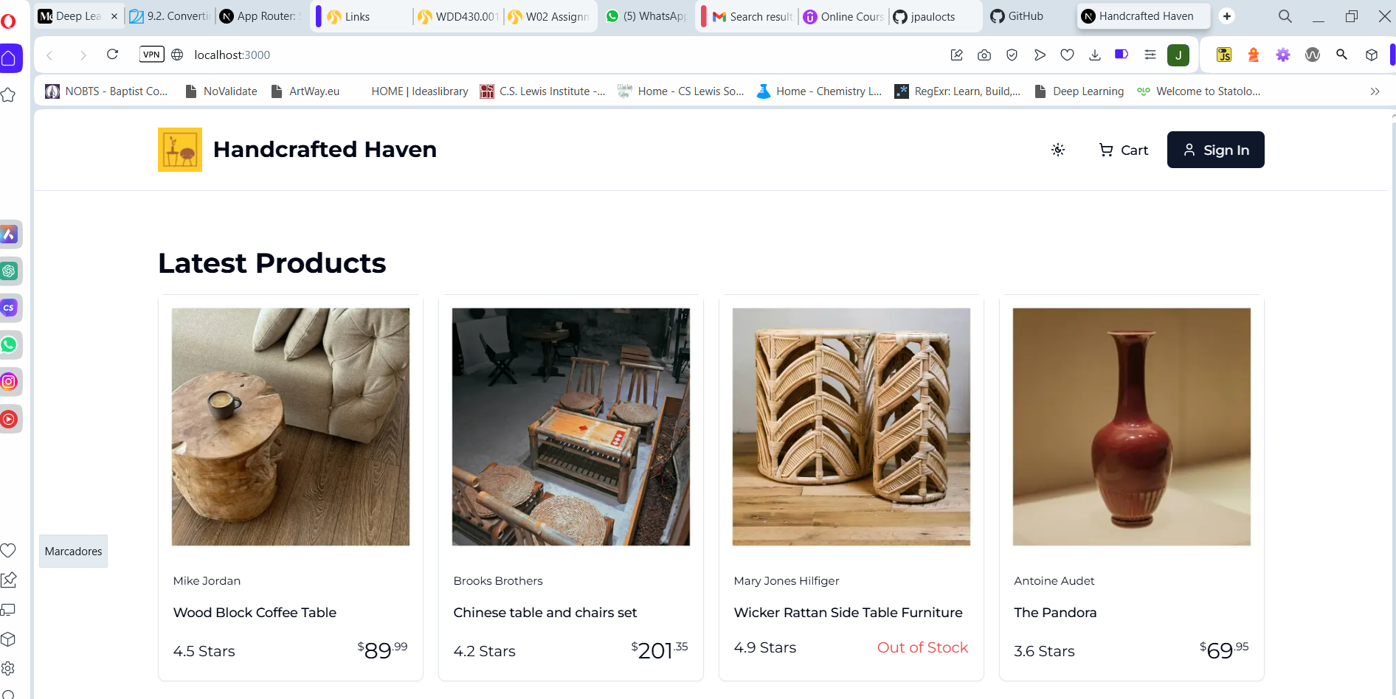

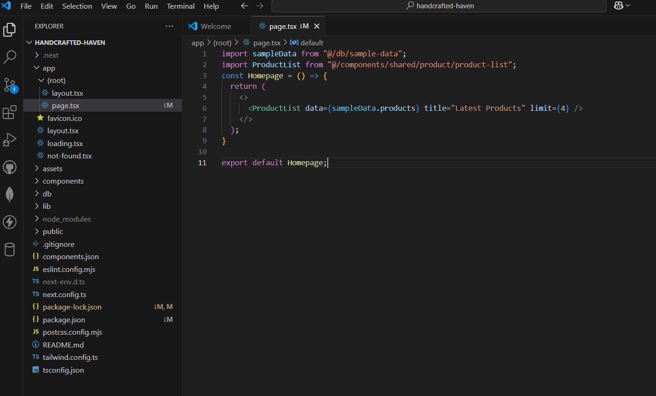

**Design and Styling Identify:** Please see additional document named site plan (PDF file).

**User Stories and Work Items:** Please see additional document named site plan (PDF file).